# Parameters

## Question: 1

Why are parameters useful?

They allow us to tailor functions to be used in multiple situations

They allow us to change the order of commands in a function

They give us the ability to use variables in loops

They allow the user to give input

## Question: 2

How many parameters can we use in each function?

1

2

4

As many as we need

## Question: 3

What is the best way to write a program that uses parameters to draw a square with sides that are 50 pixels long?

1. 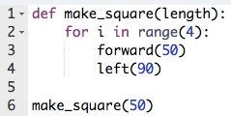
2. 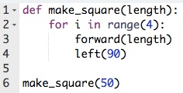
3. 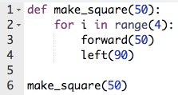
4. 